Create IBM DB2 And Connect With Python

|  |  |
| --- | --- |
| Date | 12 November 2022 |
| Team ID | PNT2022TMID19691 |
| Project Name | NUTRITION ASSISTANT APPLICATION |

**IBM DB2:**

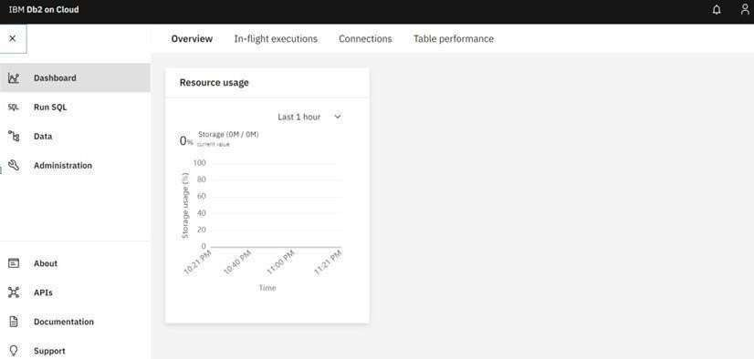

**DB2 with python:**

